DESIGN OF AN  
ONLINE FLIGHT RESERVATION SYSTEM

Submitted in partial fulfillment of the requirements for final SAD Project

**Submitted For:**

**Dr-Mohamed Hassan**

**Dr-Rasha M.Badry**

**Eng-Azza Mohamed**

Submitted By:

1-Mohamed Mostafa Mohamed

2-Shrouk Abdelnasser Mohamed

3-Mohamed Abdelhamid hamid

4-Yasmeen Khaled Kotb

5-Ahmed Ayman Salah

6-Shadan Khaled Ibrahim

Contents

**1-Introduction . . . . . . . . . . . . . . . . . . . . . . . . . . . . . . . . . . . . . . . . . . . . . . . . . . . . . . .** 2

**2-Objectives of the system:. . . . . . . . . . . . . . . . . . . . . . . . . . . . . . . . . . . . . . . . . .** 3

**3-Requirements Collection. . . . . . . . . . . . . . . . . . . . . . . . . . . . . . . . . . . . . . . . . . . . .** 3

**4-Function Requriements. . . . . . . . . . . . . . . . . . . . . . . . . . . . . . . . . . . . . . . . . . . . . .** 4

**5-Process Modeling. . . . . . . . . . . . . . . . . . . . . . . . . . . . . . . . . . . . . . . . . . . . . . . . . . .** 5

5.1-Context Diagram**. . . . . . . . . . . . . . . . . . . . . . . . . . . . . . . . . . . . . . . . . . . . . . . . .** 5

5.2-Data Flow Diagram**. . . . . . . . . . . . . . . . . . . . . . . . . . . . . . . . . . . . . . . . . . . . . . .** 6

**6-Use Case Model. . . . . . . . . . . . . . . . . . . . . . . . . . . . . . . . . . . . . . . . . . . . . . . . . . . . .**7

6.1-Use Case Diagram**. . . . . . . . . . . . . . . . . . . . . . . . . . . . . . . . . . . . . . . . . . . . . . . .** 7

6.2-Use Case analysis**. . . . . . . . . . . . . . . . . . . . . . . . . . . . . . . . . . . . . . . . . . . . . . . . .**7

**7-Activity Diagram. . . . . . . . . . . . . . . . . . . . . . . . . . . . . . . . . . . . . . . . . . . . . . . . . . .**27

**8-System Sequence. . . . . . . . . . . . . . . . . . . . . . . . . . . . . . . . . . . . . . . . . . . . . . . . . . .**28

**9-Sequence Diagram. . . . . . . . . . . . . . . . . . . . . . . . . . . . . . . . . . . . . . . . . . . . . . . . .** 29

**10-Class Diagram. . . . . . . . . . . . . . . . . . . . . . . . . . . . . . . . . . . . . . . . . . . . . . . . .** 30

**11-Summary. . . . . . . . . . . . . . . . . . . . . . . . . . . . . . . . . . . . . . . . . . . . . . . . . . . . . .** 30

**12-Refernces. . . . . . . . . . . . . . . . . . . . . . . . . . . . . . . . . . . . . . . . . . . . . . . . . . . . .** 31

**1-Introduction:**

In science and technology, the desire for improvement is a constant subject which triggers advancements. This is visible in every ramification and the airline industry is not an exemption. Airline reservation systems were first introduced in the late 1950s as relatively simple standalone systems to control flight inventory, maintain flight schedules, seat assignments and aircraft loading. Today modern airline reservation systems are comprehensive suites of products to provide systems that assist with a variety of airline management tasks and service customer needs from the time of initial reservation through completion of the flight.

The World Wide Web has become tremendously popular over the last four years, and currently most of the airlines have made provision for online reservation of their flights. The Internet has become a major resource for people looking for making reservations online without the hassle of meeting travel agents by implementing an online reservation system this ensures that reservation are not only generated by the airline own staff but also by any travel agent using a Global Distribution system or other airlines that have a multilateral Interline Traffic Agreement with the airline.

A Computer Reservations System is a [computerized](http://en.wikipedia.org/wiki/Computer) system used to store and retrieve information and conduct transactions related to travel. Computer reservation systems are classified as Passenger Service Systems (PSS) which handles a series of critical functions for the airline. For an Airline, the reservation system is a mission critical system that should use the latest state of the art technology to provide for all flight reservations on a robust platform, which is flexible and can be adapted to any style of airline. Secure and stable systems are vital to the airline industry which is why companies spend many years designing an architecture specifically suited to the nature of the airline industry which often requires tens of thousands of users to access and use the system simultaneously.

Rwenzori Airlines started as a small airline carrier in 1989 to facilitate air travel between Uganda and the Democratic Republic of Congo. This airline was to facilitate transportation of cargo between the two countries. The airline was originally designed to handle small number of customers. In 1999 Rwenzori Airline was transformed into an International Airline facilitating travel of tens of thousands of passengers on a daily basis. Today Rwenzori Airlines still use a manual system of flight booking, flight management and scheduling. Flight booking is done through travel agents across major towns, flight data and customer details are kept in manual files. This system is slow and results into booking conflicts, vacant seats in some planes and it is hard to quickly obtain customer information in case of emergency. It’s for this reason, the researcher set out to design an online airline reservation system to provides a modern, flexible reservation and inventory management solutions including call Centre, travel agency, internet engine, global distribution systems and interlines booking with case study of Rwenzori Airlines

# **2-Objectives of the system:**

* Get accuracy.
* Result to be received very quickly.
* It uses concept of user friendliness.
* It provides using of multiple applications at a time.
* Increase security, speed, storing and accuracy.
* Customer services can not only be satisfied but also enhanced to the extent that one
* can obtain or cancel a reservation from any branch for any route at any given time.

# **3-Requirements Collection**

The requirement determination involved the collection of information about how the system should operate. The requirements determination activity was the most difficult part of systems analysis. It involved gathering and documenting of the true and real requirements for the system being developed. In here the researcher was primarily thinking and trying to answer the question,

"What must the system do?" This information was used to identify the users‟ requirements and the system specifications.

**3.1-Requirements Analysis**

The primary goal of this phase was to create a detailed Functional Specification defining the full set of system capabilities to be implemented, along with accompanying data and process models illustrating the information to be managed and the processes to be supported by the new system

It involved examination of the collected data. Models such as Data Flow Diagrams (DFD) were used to model individual processes and data respectively. Under here requirements were classified as functional and nonfunctional requirements, the determination and analysis of requirements helped the researcher to achieve his second objective.

# **Function Requriements**

|  |  |  |
| --- | --- | --- |
| Function | Function  description | Actor |
| Login | Customer can submit his account info to login into the website hence use the system features. | **Customer** |
| Register | If the customer does not have account, he can register for one through this process. | **Customer** |
| Check Ticket Status | Customer can check his ticket status. | **Customer** |
| Reserve locally | customer can to request a reservation for a local ticket. | **Customer** |
| Reserve Internationally | Customer can request a reservation for an international ticket. | **Customer** |
| Cancel Ticket | Customer can make cancel request for his ticket | **Customer** |
| Manage Ticket | Customer can manage his account. | **Customer** |
| Edit information | Customer can edit his personal information | **Customer** |
| Manage | Admin can manage the services of the website. | **Admin** |
| Add reservation | Admin can confirm customer request to add a reservation | **Admin** |
| Edit reservation | Admin can confirm customer request to edit a reservation | **Admin** |
| Delete reservation | Admin can confirm customer request to delete a reservation | **Admin** |
| Delete customer account | Admin can confirm customer request to delete his account. | **Admin** |

# **5-Process Modeling**

This section describes the tools that were used to develop and implement the system. These include the context diagram, level zero, and one data flow diagram. These tools helped in designing the system and coming up with the main concept and logic of the system. Once information systems development progressed to the design activities, the researcher who was at the same time systems analyst and programmer focused his attention on the question, "How does the system do what it is supposed to do.

## 5.1-Context Diagram

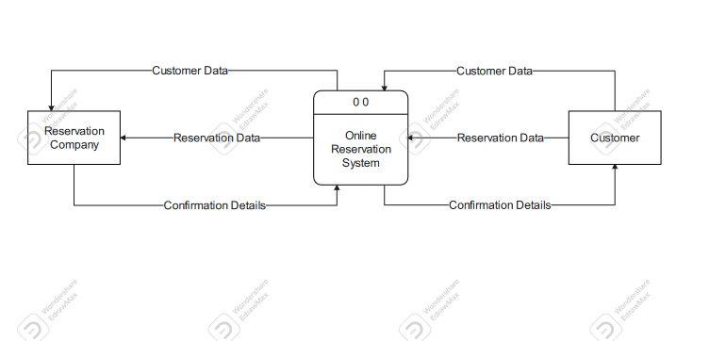

Description:-

A context diagram is a high-level view of a system. It’s a basic sketch meant to define an entity based on its scope, boundaries, and relation to external components like stakeholders

Otherwise known as a Level 0 data flow diagram, a context diagram provides a general overview of a process, focusing on its interaction with outside elements rather than its internal sub-processes. The latter is typically reserved for more advanced data flow diagrams.

## 5.2-Data Flow Diagram

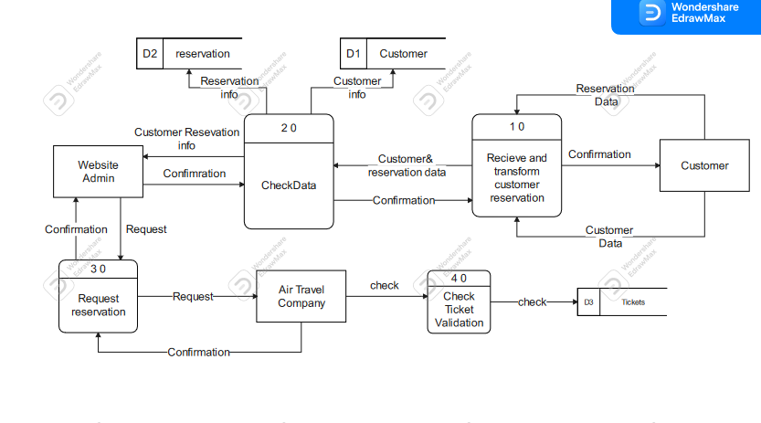

Description:-

A data flow diagram (DFD) maps out the flow of information for any process or system. It uses defined symbols like rectangles, circles and arrows, plus short text labels, to show data inputs, outputs, storage points and the routes between each destination. Data flowcharts can range from simple, even hand-drawn process overviews, to in-depth, multi-level DFDs that dig progressively deeper into how the data is handled. They can be used to analyze an existing system or model a new one. Like all the best diagrams and charts, a DFD can often visually “say” things that would be hard to explain in words, and they work for both technical and nontechnical audiences, from developer to CEO. That’s why DFDs remain so popular after all these years. While they work well for data flow software and systems, they are less applicable nowadays to visualizing interactive, real-time or database-oriented software or systems.

# 6-Use Case Model

The next method for representing and analysis the system is use case modelling and it consists of use case diagram and use case analysis.

## 6.1-Use Case Diagram

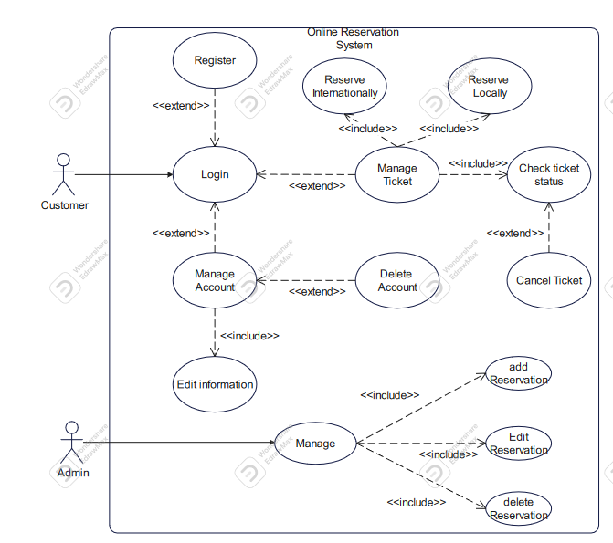

## 6.2-Use Case analysis

|  |  |  |
| --- | --- | --- |
| Use case Name: | Login | |
| Actor(s): | Customer | |
| Description: | This use case describes the process of a customer login to the website, the customer will receive a  message whether the login succeed or not. | |
| Typical Course of Events: | Actor Action | System Response |
|  | **Step 1:**  This use case is initiated when a customer submits an login information. | **Step2:**  The customer personal information such  as username & password is validated. |
| Alternate Courses: | **Step3:** If the user credentials weren’t correct, he can retrieve his password or username through e-mail.  **Step4:** If the user didn’t have account, he can register for new one. | |
|  | **Step5: If the user credentials were correct, he can continue to use the system features.** | |
| Precondition: | **Username and password can only be submitted by the customer himself.** | |
| Post condition: | **Customer credentials has been recorded.** | |
| Assumption: | **None at this time.** | |

|  |  |  |
| --- | --- | --- |
| Use case Name: | Register | |
| Actor(s): | Customer | |
| Description: | This use case describes the process of a customer  register to the website, the customer will receive a  message with register confirmation |  |
| Typical Course of Events: | Actor Action | System Response |
|  | **Step 1:**  This use case is initiated when a customer submits an register information. | **Step2:**  The customer personal information such  as username & password is recorded. |
| Alternate Courses: | Step3:  if customer had account before he will be redirected to the LOGIN page | |
| Precondition**:** | Username and password can only be submitted by the customer himself not bot | |
| Post condition: | Customer register information has been recorded. | |
| Assumption: | Not this time | |

|  |  |  |
| --- | --- | --- |
| Use case Name: | Manage Ticket | |
| Actor(s): | Customer | |
| Description: | Customer can manage his tickets through this process | |
| Typical Course of Events: | Actor Action | System Response |
|  | **Step1:**  This use case is initiated when a  Customer wants to manage his tickets, he can reserve a ticket locally or internationally, if he already had a ticket he can check its status or cancel it. | **Step2:**  If the customer wanted to reserve a ticket locally, the system calls use case RESERVE LOCALLY, If the customer wanted to reserve a ticket locally, the system calls use case RESERVE Internationally, If the customer wanted check ticket status the system calls use case CHECK TICKET STATUS, if he  wanted to cancel current ticket the system calls use case CANCEL TICKET |
| Precondition**:** | **The customer must login.** | |
| Post condition: | **Customer proceeds to another use cases.** | |
| Assumption: | **Not at this time** | |
| Alternate Courses: | Not at this time | |

|  |  |  |
| --- | --- | --- |
| Use case Name: | Reserve Locally | |
| Actor(s): | Customer | |
| Description: | Customer can request a local ticket through this process, the customer receives message with reservation details. | |
| Typical Course of Events: | Actor Action | System Response |
|  | **Step1:**  This use case is initiated when a  Customer wants to request local ticket. | **Step2:**  System checks personal information for customer information data base |
|  | Step3: system check the availability  of the ticket from tickets database. |
|  | Step4: system record the ticket reservation in the reservation database. |
|  | Step5: system send message with the reservation details to the customer. |
| Step6: use case concludes when the customer receives message with his local ticket details. |  |
| Alternate Courses: | Step3: if something missing from personal information the system sends notification the customer.  Step4: if the desired ticked was out of stock the system sends notification to the customer. | |
| Precondition**:** | **Not this time** | |
| Post condition: | **Local ticket recorded in the reservation database.** | |
| Assumption: | **Not at this time** | |

|  |  |  |
| --- | --- | --- |
| Use case Name: | Reserve internationally | |
| Actor(s): | Customer | |
| Description: | Customer can request a international ticket through this process, the customer receives message with reservation details. | |
| Typical Course of Events: | Actor Action | System Response |
|  | **Step1:**  This use case is initiated when a  Customer wants to request international ticket. | **Step2:**  System checks personal information for customer information data base |
|  | Step3: system check the availability  of the ticket from tickets database. |
|  | Step4: system record the ticket reservation in the reservation database. |
|  | Step5: system send message with the reservation details to the customer. |
| Step6: use case concludes when the customer receives message with his local ticket details. |  |
| lternate Courses: | Step3: if something missing from personal information the system sends notification the customer.  Step4: if the desired ticked was out of stock the system sends notification to the customer. | |
| Precondition**:** | **Not this time** | |
| Post condition: | international **ticket recorded in the reservation database.** | |
| Assumption: | **Not at this time** | |

|  |  |  |
| --- | --- | --- |
| Use case Name: | Check Ticket status | |
| Actor(s): | Customer | |
| Description: | Customer can check status of his ongoing ticket. | |
| Typical Course of Events: | Actor Action | System Response |
|  | **Step1:**  This use case is initiated when a  Customer wants to check status of ticket. | **Step2:**  System checks personal information for customer information data base |
|  | Step3: system check ticket  information from the reservation database. |
|  | Step4: system send message with the ticket details to the customer. |
| Step6: use case concludes when the customer receives message with his ticket details. |  |
| Alternate Courses: | Step1:if the customer wanted to cancel the ticket the system deletes the ticket information for the reservation database then refund the credits to the customer. | |
| Precondition**:** | **There’s must be a ticket** | |

|  |  |
| --- | --- |
| Post condition: | **if he wanted to check status, he gets message with the status details,if he wanted to cancel the ticket, he gets refund for credits.** |
| Assumption: | **Not at this time** |

|  |  |  |
| --- | --- | --- |
| Use case Name: | Manage account | |
| Actor(s): | Customer | |
| Description: | Customer can manage his account via this process, he can edit information or delete the account, and he gets message with confirmation of editing info or deleting account. | |
| Typical Course of Events: | Actor Action | System Response |
|  | **Step 1:** | **Step2:**  If the customer chose edit info the system calls edit info use case. |
| This process initiates when a  Customer wanted to edit info or delete account. | Step3:If the customer chose delete account, the system first checks if there is current active tickets. |
|  | Step4:  The system calls delete account info use case. |
| Customer gets message with confirmation of editing info or deleting account. |  |
| Alternate Courses: | **Step4:if the account had active tickets, then the system send notification to the customer before calling delete account use case** | |
| Precondition**:** | **Customer must have account on the system** | | |
| Post condition: | **Account info of the customer either edited or deleted.** | | |
| Assumption: | **Not this time** | | |

|  |  |  |
| --- | --- | --- |
| Use case Name: | Edit account | |
| Actor(s): | Customer | |
| Description: | Customer can edit his account information via this process, | |
| Typical Course of Events: | Actor Action | System Response |
|  | **Step 1:**  This process initiates if the Customer wanted to edit info  Customer gets message with confirmation of editing info. | **Step2:**  The system takes the new info from the user and replace it in the customer database. |
| Alternate Courses: | **Step2:**  **If the new info weren’t completed the system send notification to the customer to enter the info again** | |
| Precondition**:** | **Customer must have account on the system** | |
| Post condition: | **Account info of the customer r edited.** | |
| Assumption: | **Not this time** | |

|  |  |  |
| --- | --- | --- |
| Use case Name: | Delete account | |
| Actor(s): | Customer | |
| Description: | Customer can delete his account information via this process, | |
| Typical Course of Events: | Actor Action | System Response |
|  | **Step 1:**  This process initiates if the Customer wanted to delete his account  Customer gets message with confirmation of editing info. | **Step2:**  The system takes checks if there is any tickets reserved from tickets database.  Step3: if there is no tickets reserved the system wipe out customer info from the customer database and send confirmation message.  **Step4: if there is any tickets reserved the system sends notification to the customer to cancel his reservation before deleting the account.** |
| Alternate Courses: | **Not at this time** | |
| Precondition**:** | **Customer must have account on the system** | |
| Post condition: | **Customer’s account is deleted.** | |
| Assumption: | **Not this time** | |

|  |  |  |
| --- | --- | --- |
| Use case Name: | Manage | |
| Actor(s): | admin | |
| Description: | Admin can manage reservation requests came from the customers, the admin can edit, add or delete reservations. | |
| Typical Course of Events: | Actor Action | System Response |
|  | **Step 1:** | **Step2:** |
| This process when the admin want to manage reservations. | **If the admin wanted to edit reservation the system checks the reservation details from reservation database.** |
|  | **Step3: The system calls edit reservation use case.** |
|  | **Step4:** |
|  | **If the admin wanted to delete reservation the system checks the reservation details from reservation database.** |
|  | **Step5: The system calls delete reservation use case.** |
|  | **Step6:** |
| Step8: this use case concludes the customer and the admin receives message from the system. | **If the admin wanted to add reservation the system checks the reservation details from reservation database.** |
|  | **Step7: The system calls add reservation use case.** |

|  |  |  |
| --- | --- | --- |
|  |  | **Step9: system sends notification to the customer with the confirmation details and to admin with the actions happened.** |
| Alternate Courses: | **Not at this time** | |
| Precondition**:** | **Admin should has authority to make actions.** | |
| Post condition: | **Customer reservation either edited, deleted or new reservation added.** | |
| Assumption: | **Not this time** | |

# **7-Activity Diagram**

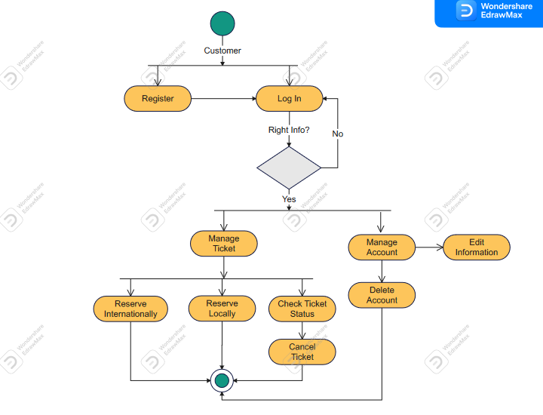

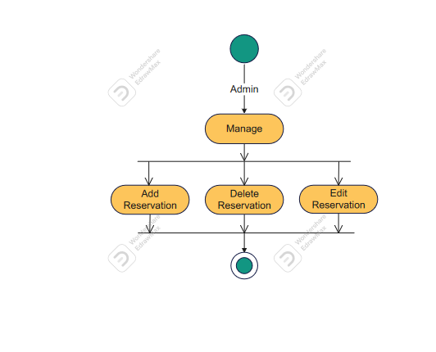

# **8-System Sequence**

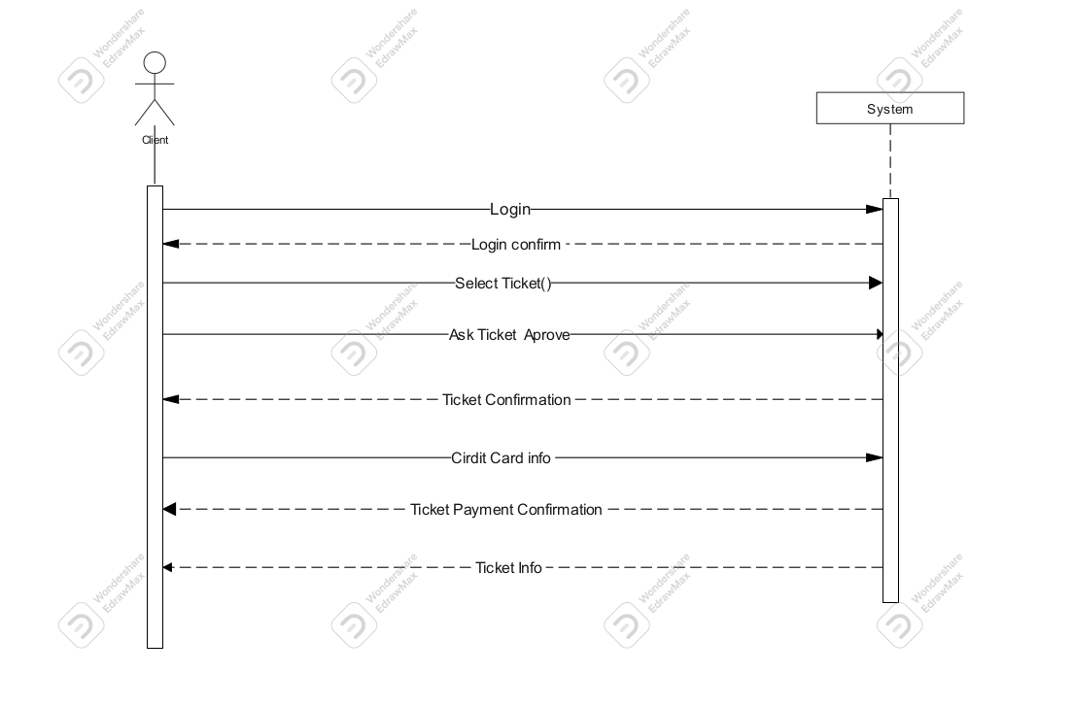

# **9-Sequence Diagram**

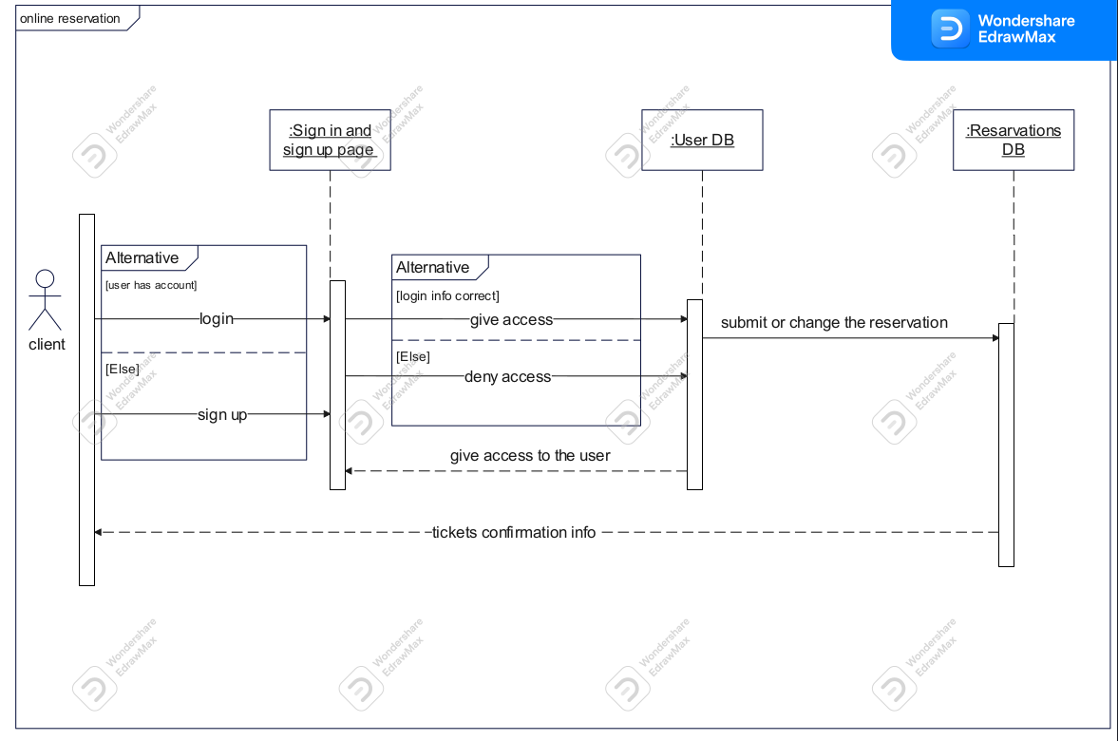

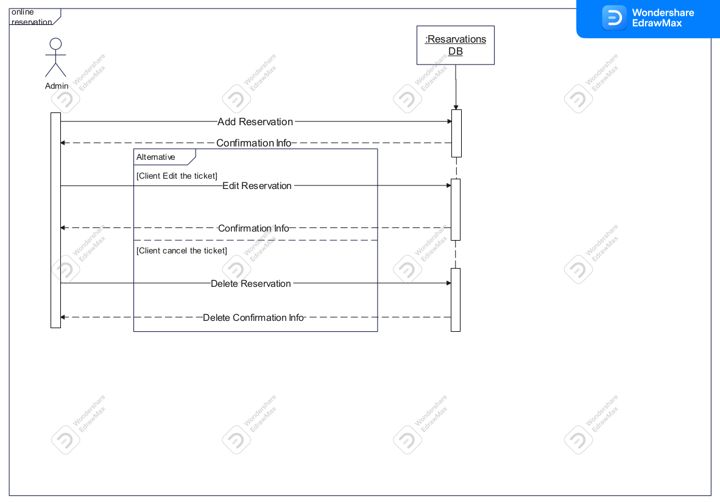

**10-Class Diagram**

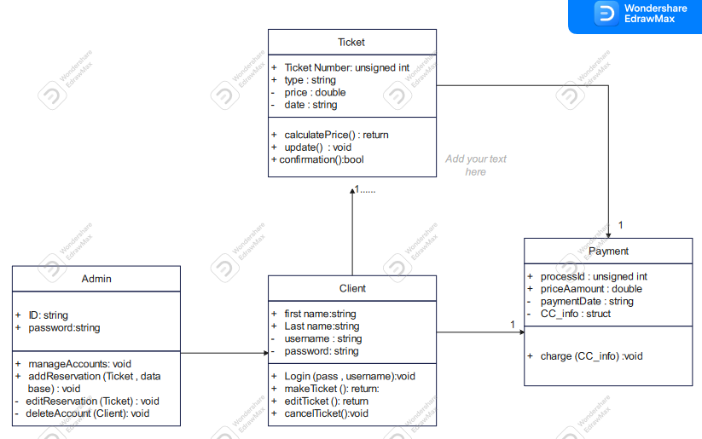

**11-Summary:**

At the end, we conclude the documentation of the system with its pros and cons.

**Advantages of Airline reservation system**

* The Airline reservation system has been a way of minimizing the clerical work, which  
  is almost a routine and consumes the most precious time.
* This AIRLINE RESERVATION SYSTEM has been an attempt to help the user to  
  minimize his workload along with minimizing the paper works and saving of time.
* The system has been developed in a way to make it very user friendly. It provides an  
  on-line message and an error detection and error messages every time the user needs.
* Any person having a little bit of window based can run this system without any pain.
* Almost all the difficulties of manual reservation have been removed by this system.
* wind up let me welcome all the suggestions and other improvements, which the system needs  
  so that it covers all the needs if the user in the user way.

**Disadvantages of Airline reservation system**

* You need to be ready for an influx of new customers

Online booking software is a great way to attract new customers, many of whom prefer booking online from their computers and mobile devices. However, if you’re running a small operation without enough staff members or resources to expand your activities, growing too quickly may pose a challenge.

* Our system is bit expensive but we provide a maintenance session for free only for the first time.
* You need stable Internet access

If you run tours and activities in remote areas where you aren’t able to get on stable Internet, online booking might not be for you. You’ll need reliable Internet access to check your reservations and to add bookings that are made online.

# 

# **12-Refernces**

Airline, 2012 http://www.enotes.com/topic/Airline_Reservations_System retrieved on

23. May 2012

Alter, S. L. (1980). Decision support systems: current practice and continuing challenges. Reading, Mass., Addison-Wesley Pub.

Aviation and Space. Retrieved on May 20, 2012 from Microsoft Encarta Premium 2009 E Encyclopedia.

C. Winston, S. Morrison (1995): "The Evolution of the Airline Industry", Brookings Institution Press, South Dakota, Cf. p. 61-62, Computer Reservation Systems.

Computerized Reservation System. Retrieved on May 14, 2012 fromhttp://en.wikipedia.org/wiki/Computer_reservations_system.htm.

Diane (1993) Computer Reservation Systems: “Action Needed to Better Monitor the CRS Industry and Eliminate CRS Biases”, DIANE Publishing Company, ISBN1568069774

European Parliament: “More Competition in Airline Reservation System – With

Finley, P. N. (1994). Introducing decision support systems. Oxford, UK Cambridge, Mass. NCC Blackwell; Blackwell Publishers.

Global (2012 ) http://www.businessdictionary.com/definition/Global-DistributionSystem- GDS.html accessed on May 26, 2012

Henry R. Luce (2001) “The Rise of the American News Media” The Johns Hopkins University Press (July 12, 2001)

James a. O’Brien (2001) n (2001). Management information system

Kantar, (1997). Managing with information. 4th edition

M. J. Smith (2002): “The Airline Encyclopedia, 1909 – 2000”. Scarecrow Press, New York.